Chapter 12: IPv6 addressing
IPv4 issues
Need for IPv6
- Almost running out of IPv4s addresses (4.3 billion addresses).
- Contains a bigger addressing space: IPv6 brings more than 340 undecillion addresses
- Considered the limitation of IPv4 so there were new feature and enhancements
- There’s no need for public/private addressing translation.
- As the internet evolves it’s became an Internet of Things: meaning you can connect pretty much any device to a network, and those devices require an IP.

IPv4 and IPv6 coexistence
- Moving from IPv4 is a process that takes time so while we make that transition there are different ways for IPv4 and IPv6 to coexist.
- Dual-stack: devices run both versions simultaneously.
- Tunneling: an IPv6 packet will be encapsulated inside an IPv4 packet while the packet travels through a IPv4 network.
- Translation: uses Network Address Translation 64 (NAT64) which is a technique similar to NAT, so IPv6 devices can communicate with IPv4 devices.

IPv6 Address Representation
- Its 128 bit long.
- Uses hexadecimal system.
- It groups the bits on “hextets” (16 bits) separated by a colon (:).
- Each hexadecimal value is comprised of 4 bits, and their values can go from 0 to f (not case sensitive).
- Uses a prefix -the slash notation- to identify the network/host portions (host portion is known as the interface ID).
- It can be represented in two formats: preferred and compressed.
- There are two rules for the compressed format:
  - Omit leading zeros on a hextet 2001:0db8:0000:1111:0000:0000:0000:0200 2001:db8:0:1111:0:0:0:200
  - Double colon ( :: ) can replace any single (continuous) string of hextet containing all zeros this rule can only be once. 2001:0db8:0000:1111:0000:0000:0000:0200 2001:db8:0:1111::200

IPv6 Address Types
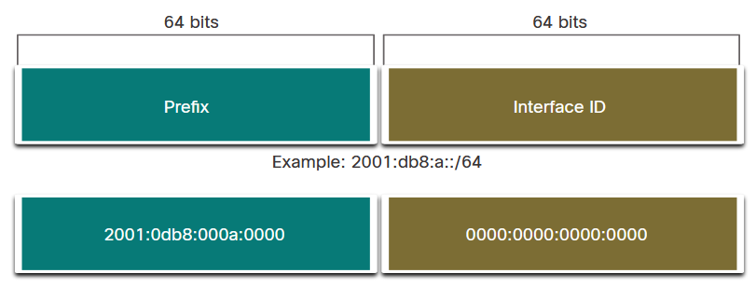
Unicast, Multicast, Anycast
- There are no broadcast addresses, instead it uses some special multicast addresses.
- Multicast: function similar to IPv4 multicast addresses, to communicate with multicast group of hosts. They will start with the network prefix: ff00::/8
  - Well-known multicast addresses:
    - ff02::1 All nodes on the local network segment
    - ff02::2 All routers on the local network segment
- Anycast: several devices are assigned the same IPv6 address (e.g., 3 servers offering the same service) and the sender will address the packet with the anycast address and the device that is the closest (in routing distance) will receive the packet. This is a special unicast address (out of CCNA scope).
- Unicast: uniquely identifies an interface (device). *please keep in mind that a device can have more than 2 IPv6 addresses.
  - Three types of Unicast addresses:
    - Global Unicast Address (GUA): internet routable. Begins either with a 2 or 3 (2800:0000::/12 2001:1200::/23 LACNIC).
    - Link-local address (LLA): used for local communication within a specific LAN only. Begin with a FE80
    - Unique Local: should *NOT* be routed over the Internet, function similar to private IPv4 addresses. Will begin within range fc00::/7 to fdff::/7.

Link-local:
Imagine this: you have a car but cannot go to other cities even withing your country, you can only navigate your own city; the link local can be used only on a segment of the whole org’s network (withing one broadcast domain). For example, hosts on the Sales Department can only talk to other hosts on the same department, if they need to communicate with a host on the Human Resources dept they won’t be able to do so as the HR Dept will be on a different segment of the network.

Unique Local/Site Local
Imagine this: you can use a car to drive through Costa Rica, you’re not limited to only a province or city, but you cannot go out of CR (trespass to another country); the Unique Local can be used by an organization throughout all their private network, but not outside, meaning the internet.

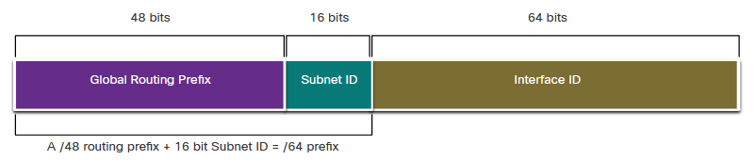

Static IPv6 Configuration
- To enable L3 devices to route IPv6: ipv6 unicast-routing
- Most commands for ipv4 configuration can be used in IPv6 the difference is that instead of ip the command will be ipv6:
- IPv4 command: show ip interface brief
- IPv6 command: show ipv6 interface brief

GUA configuration
- Enable IPv6 routing on global configuration mode
Router(config)# ipv6 unicast-routing
- Assign an IP to an interface
Router(config)#interface [id] [number]
Router(config-if)# ipv6 address [ipv6address]/[prefix]
Router(config-if)# no shut
Example
Router(config)#interface g0/1
Router(config-if)# ipv6 address 2001:db8:acad:1::1/64
Router(config-if)# no shut

LLA configuration
Router(config)#interface [id] [number]
Router(config-if)# ipv6 address ipv6-link-local-address link-local
Router(config-if)# exit
Example
Router(config)# interface GigabitEthernet 0/0
Router(config-if)# ipv6 address fe80::1:1 link-local
Router(config-if)# exit

Dynamic Addressing for IPv6 GUAs
RS and RA Messages
- They’re part of the ICMPv6 protocol.
- They will be exchanged between IPv6 routers (layer 3) and IPv6 devices.
- Router Advertisement (RA): periodically (every 200 seconds) sent by IPv6 routers, can also be a response to a router solicitation.
- Router Solicitation (RS): sent by IPv6s to determine how it should configure the IP information dynamically (which method it should use).

Stateless Address Autoconfiguration
- SLAAC:
- The device autoconfigures its IP address based on the information provided on the RA message
- The RA can be a reply to the RS message sent by the device or just a periodic message from the router.
- the RA contains the network prefix, the prefix length, DGW.
- Information is provided by a router (through a RA message).
Important: no DHCP server is involved.
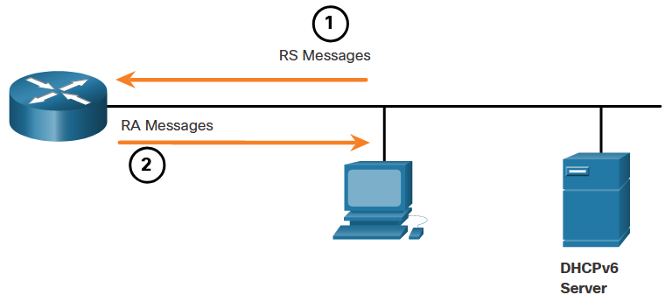
- SLAAC with stateless DHCPv6:
- The device autoconfigures its IP address based on the information provided on the RA message
- The RA can be a reply to the RS message sent by the device or just a periodic message from the router.
- The RA contains the network prefix, the prefix length, DGW.
- DNS settings and extra info is provided by a DHCP server.
Important: even though a DHCP server is present, they are *not* used to lease addresses, meaning there is no centralized administration over the IPs being used on the network.
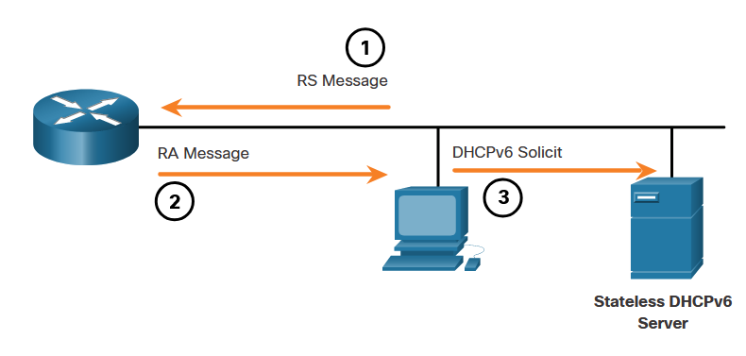

- Stateful DHCPv6 (no SLAAC):
- The devices obtain the network information from a server
- That server is in charge of the lease (assigning) IP addresses (as a whole) to the devices
- Administration of the IPs is centralized on the server.
Important: the devices still obtain the DGW information from a router.
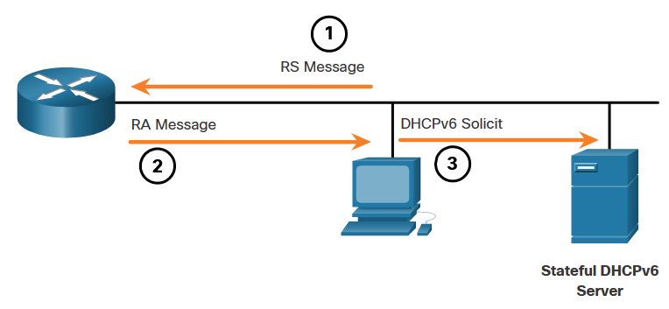

EUI-64 Process vs. Randomly Generated
- When devices use SLAAC or SLAAC with DHCPv6 they will generate their interface ID by using either a randomly generated number or use a process called EUI-64 Process.

EUI-64 Process
- Extended Unique Identifier (EUI) or modified EUI-64 process.
- It uses a device Ethernet MAC address (48-bit).
- The process itself is:
- Step 1: take the MAC of the device and divide it in two.
  - FC99:47 75:CEE0
- Step 2: insert the value FFFE between the two pieces of the MAC. (since a mac address is only 48-bit we will complete the 64 bits from the interface ID with these four hexa values)
  - FC99:47FF:FE75:CEE0
- Step 3: take the first 2 values of the MAC and covert them to binary, once this is done, revert the 7th binary value. E.g., if we have (FC) 11111100 then if we invert the 7th value it will look like this: 11111110 (FE) and then we convert back the new binary to hexadecimal.
  - FE99:47FF:FE75:CEE0
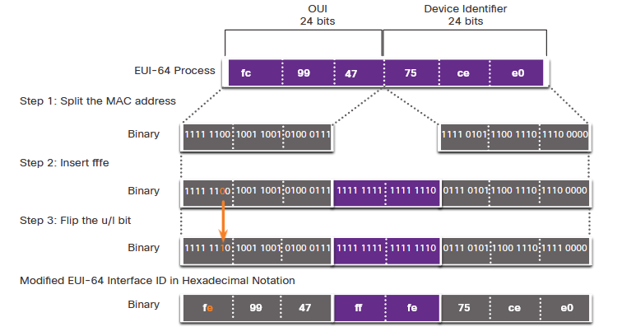

Randomly Generated Interface IDs
- As the name suggest the interface ID is randomly generated by the device.

Bonus
Global Unicast Address: Internet routable.
Link-local address: communication within one (and only one) LAN/Broadcast Domain.
Loopback address: device sends a packet to itself to test the TCP/IP stack.
Unique local address: not internet routable, work pretty much like IPv4 private addressing.
Unspecified address: absence of an address, device doesn’t have an IP assigned yet. E.g. when a device sends a packet to discover if address is already in use (DAD), they use the unspecified address as the source of the packet.
Embedded IPv4: can be used for NAT64.
Solicited node IPv6 Multicast: The packet uses L2 multicast MAC addresses.

